

DETAIL DESIGN

**Version1.0**

**Quốc Nhân**

**06/11/2019**

**VERSION HISTORY**

|  |  |  |  |  |  |
| --- | --- | --- | --- | --- | --- |
| **Version #** | **Implemented**  **By** | **Revision**  **Date** | **Approved**  **By** | **Approval**  **Date** | **Reason** |
| 1.0 | Quốc Nhân | 06/11/2019 |  |  | Create Document Detail Design version 1.0 |
|  |  |  |  |  |  |
|  |  |  |  |  |  |
|  |  |  |  |  |  |

Table of Contents

1. Introduction 3

1.1 Purpose 3

1.2 Objects 3

1.3 Definitions, Acronyms and Abbreviations 3

2. Detail design 3

2.1 Purpose 3

2.2 Detail Design Process 3

2.3 Role and Responsibility 3

# 

# Introduction

## Purpose

The document describes the work required to complete the detailed design phase of software products, including the main stages:

* Detail design phase

## **Objects**

|  |  |  |
| --- | --- | --- |
| **No** | **Readers** | **Reason for reading** |
| 1 | Project manager | Capture the schedule of the architectural stages and update the plan of the project. |
| 2 | Mentor | Survey and guidance to develop detail design plans |
| 3 | Architecture & design leader | Use this document to manage and update the detail design progress schedule. |
| 4 | Architecture & design engineer | Read this document for a detailed design plan and follow-up plan to perform the work at this stage. |

## **Definitions, Acronyms and Abbreviations**

|  |  |
| --- | --- |
| **Term or Acronym** | **Definition** |
| DL | Design Leader |
| AL | Architect Leader |
| SRS | Software Requirement Specification |
| SAD | Software Architecture Document |
| GUI | Graphic User Interface |
| DE | Design Engineer |
| SDS | Software Design Specification |

# Detail design

## Purpose

The process will define how to elicitation and analyze the detail design process, how to gathering the architecture, represent the resulting observations in adequate formats, and check the accuracy of the documents.

## **Detail design process**

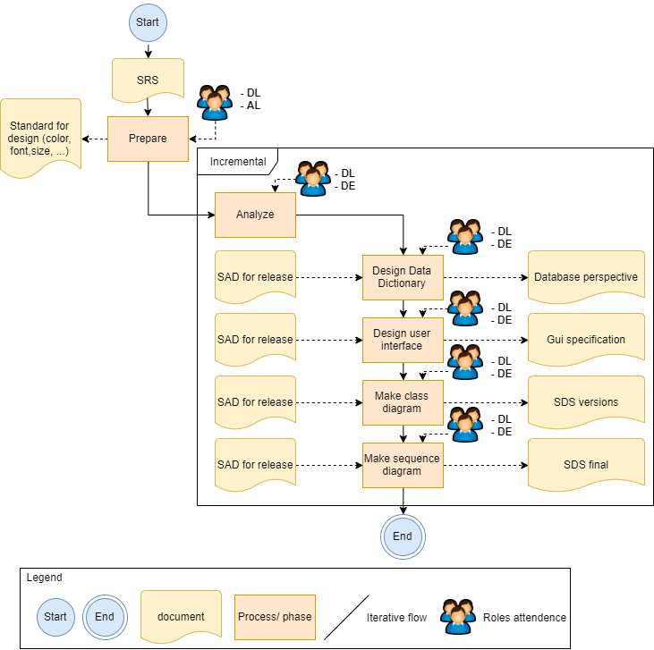

## **Role & responsibility**